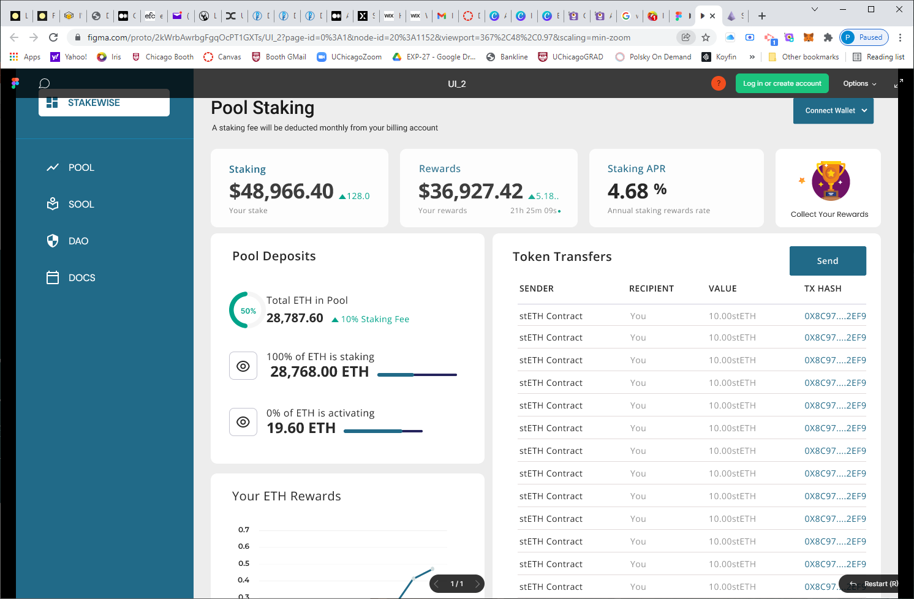

This should be Mercury not Stakewise

No Pool
SOOL is SOLO
No DAO

